|  |  |
| --- | --- |
|  | **MATHEMATICS METHODS 3 & 4**  **SEMESTER 1 2019**  **TEST 2**  **Calculator Free** |

Reading Time: 2 minutes Time Allowed: 32 minutes

Total Marks: 32

**Question 1 (6 marks)**

Determine the following indefinite integrals.

(a) 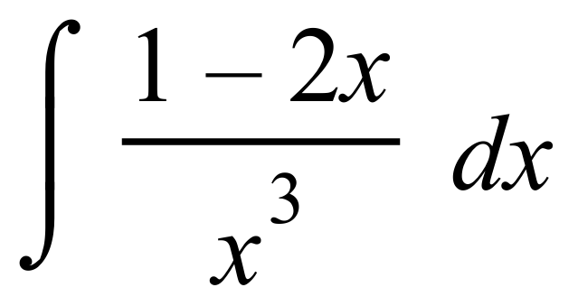 (2 marks)

(b)  (2 marks)

(c) 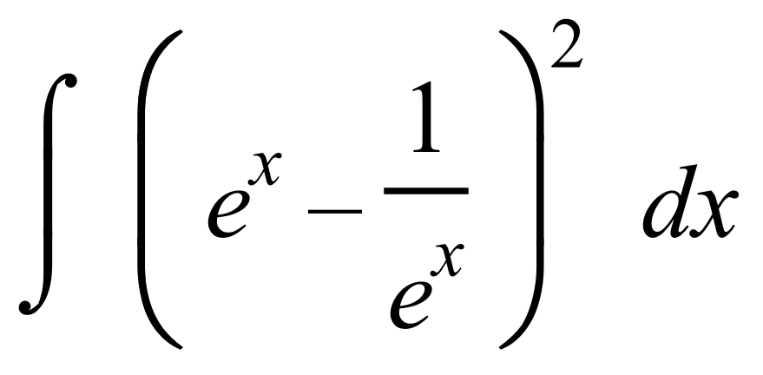 (2 marks)

Question 2 (5 marks)

Part of the graph of  is shown in the diagrams below.

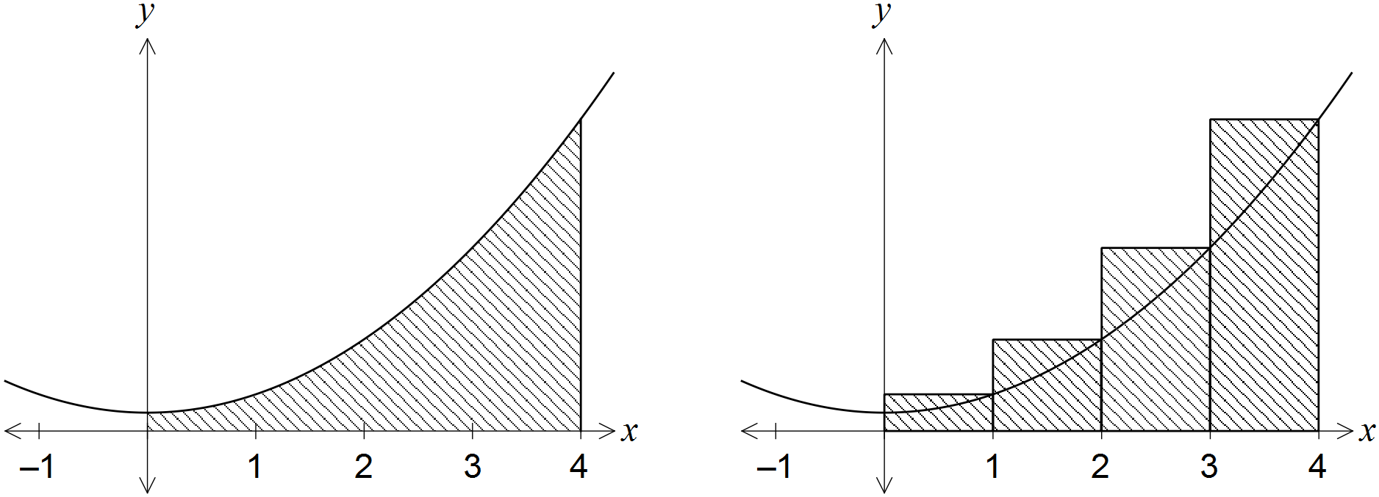

An approximation for the area beneath the curve between  and  is made using rectangles as shown in the right-hand diagram. Determine the exact amount by which the approximate area exceeds the exact area.

**Question 3 (4 marks)**

Find the area bounded by the curve  and the *x* axis from  to 

**Question 4 (3 marks)**

Determine  given that  and 

**Question 5 (10 marks)**

Consider the graph  shown below for  Each of the curved sections of  can be obtained by translating the appropriate part of the function , 

*A* is the area of the shaded region bounded by the *x* axis, the *y* axis and. *B* is the area of the shaded triangle with vertices at (2,0), (3,-8) and (4,0).

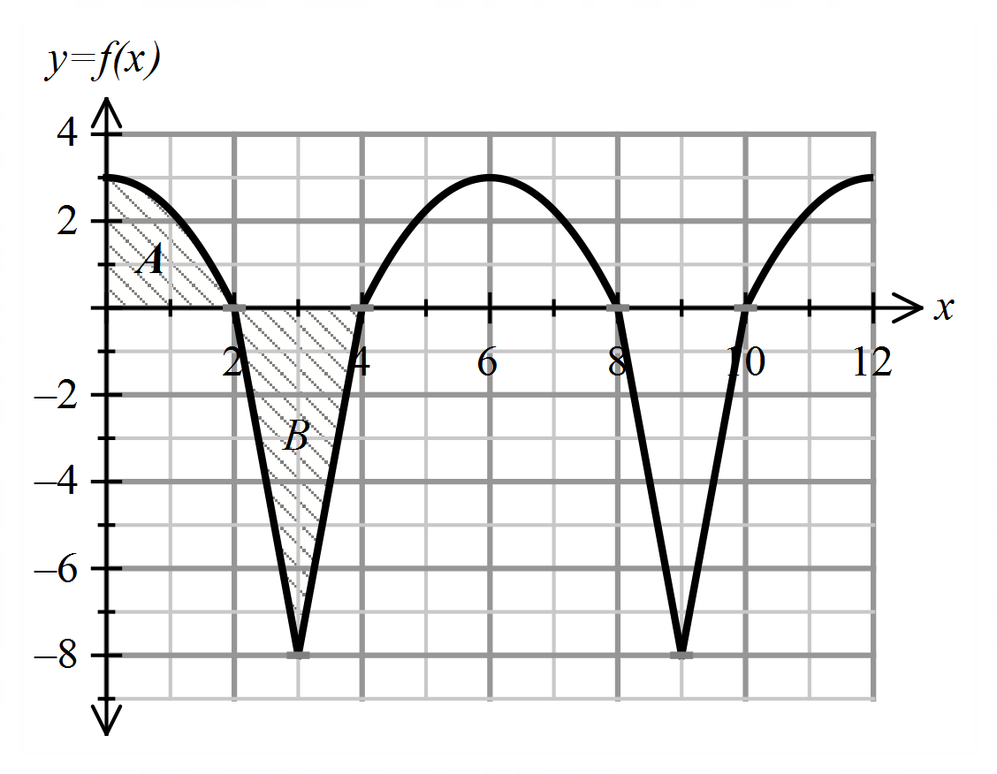

Use the graph of  where appropriate to answer the following.

(a) Express the following in terms of *A* and *B*



(1 mark)



(ii) (3 marks)

(b) Determine  (2 marks)

(c) Given that *A* = 4 square units

1. Determine the value/s of  such that  (2 marks)

1. Evaluate where  for the domain .

(2 marks)

**Question 6 (4 marks)**

The curve of the function 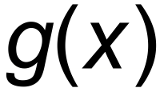 has a stationary point at (4, 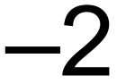) and a gradient function of

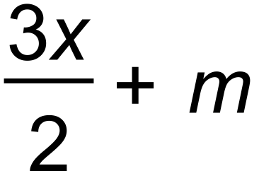 where m is a constant. Show that 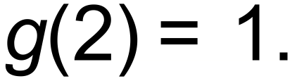

|  |  |
| --- | --- |
|  | **MATHEMATICS METHODS 3 & 4**  **SEMESTER 1 2019**  **TEST 2**  **Calculator Assumed** |

Reading Time: 2 minutes Time Allowed: 30 minutes

Total Marks: 30

**Question 7 (6 marks)**

The height of a tree is increasing at a rate of  metres per month where = 

1. Find the increase in height of the tree in the 5th month. (2 marks)
2. Find the average growth in the tree in the first 5 months. (2 marks)

The initial height of the tree was 2 metres.

1. Find the height of the tree after 2 years. (2 marks)

**Question 8 (5 marks)**

The displacement (*s*) of a particle moving in rectilinear motion can be modelled by the function  where *s* is measured in metres and time, *t,* is measured in seconds,  .

(a) Determine the rate of change of displacement with respect to time at 5 seconds.

(2 marks)

(b) During which times interval/s is the particle moving towards the origin? (3 marks)

**Question 9 (4 marks)**

Determine the exact area of the region bounded by the curves with equations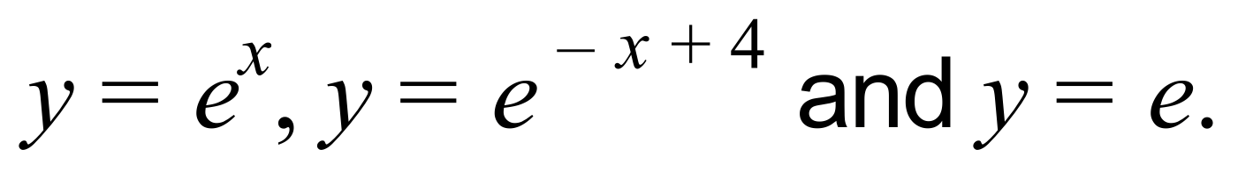

**Question 10 (7 marks)**

Consider the graph of 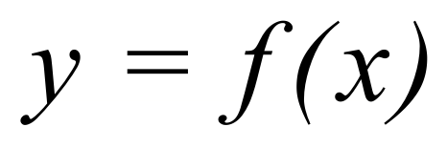 which is drawn below.

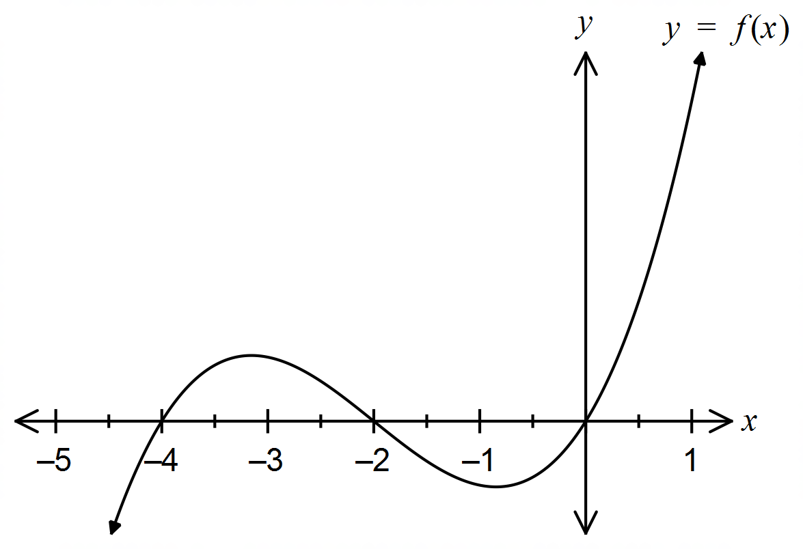

Let 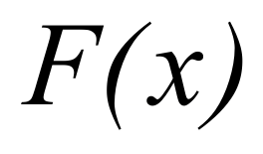 be defined by the integral 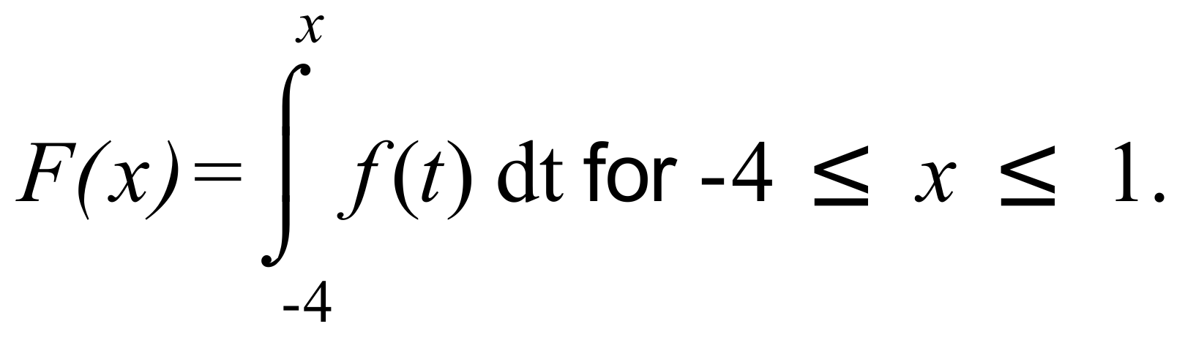

It is known that *F* has two points of inflection within the interval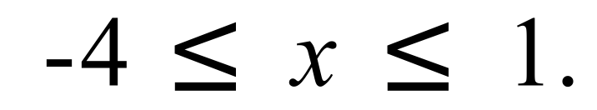

(a) Determine 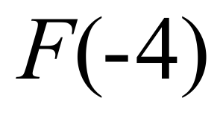. . (1 mark)

(b) For what value/s of *x* does *F* have stationary points? (2 marks)

(c) For what value/s of *x* is *F* increasing? Justify your answer. (2 marks)

(d) State the approximate values of *x* for which *F* has points of inflection within the interval  (2 marks)

**Question 11 (8 marks)**

The acceleration (ms-2) of a particle moving along a straight line is given by  where *t* is time in seconds. Initially the particle is at rest at its origin, *O*.

(a) Determine an expression for the velocity of the particle at any time *t.* (2 marks)

(b) Does the particle change direction? Justify your answer. (2 marks)

(c) Determine the average speed of the particle during its first three seconds of motion.

(2 marks)

(d) With reference to the velocity and acceleration of the particle, describe the motion of the particle at *t* = 2 seconds. (2 marks)